Chapter 11, Solution 93

- 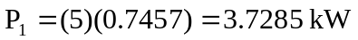
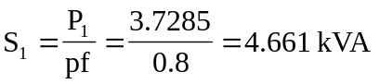
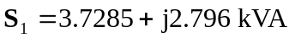

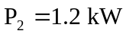, 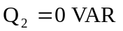
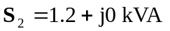

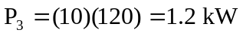, 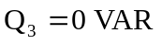
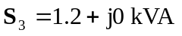

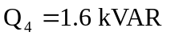, 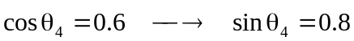
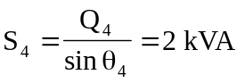
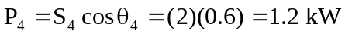
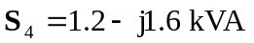

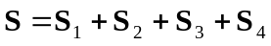
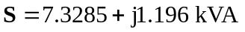

Total real power = 
Total reactive power = 

 